**FACEBOOK PAGE:**

**LINK:** [**https://www.facebook.com/profile.php?id=61550613853878**](https://www.facebook.com/profile.php?id=61550613853878)

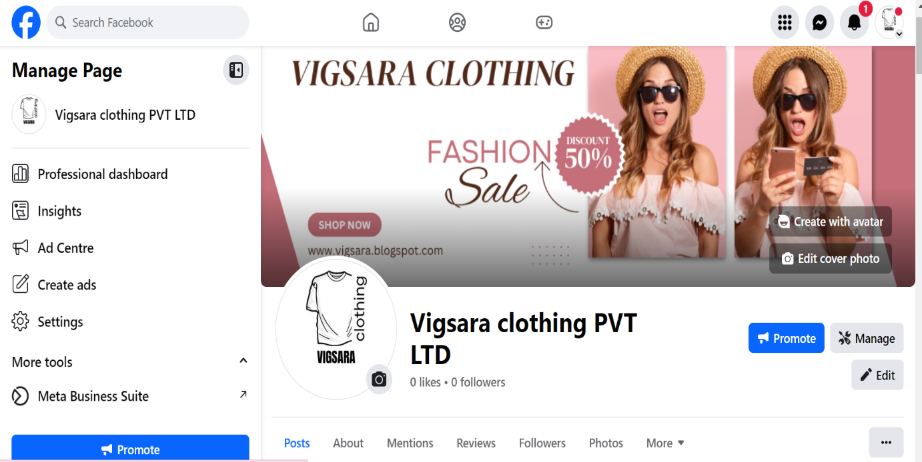

**FB POST:**

